

HOW TO BUILD A LOCKSTAR RACK

26.11.2020 – by [frank@phys.ethz.ch](mailto:frank@phys.ethz.ch)

Minimum Equipment List

|  |  |  |  |
| --- | --- | --- | --- |
| **Pos** | **Device** | **Specifications** | **Where to get it** |
| 1 | 1 x SG1-10 | - | Shop, 30411.1 |
| 2 | 4 x Threaded insert, M2.5, St, zinc-plated | - | Shop, B10 or  Distrelec via Shop |
| 3 | 1 x Rearpanel | QO-WSO-21638 | Impact Team or Workshop |
| 4 | 1 x Power Terminal | 30298.1 | Shop, B10 + Screws and Bolts |
| 5 | 1 x ETHernet cable | Adafruit 4215 | Adafruit or Mouser 485-4215 |
| 6 | 1 x Ground Slug + Screw | 3838 E | Shop 30115.1 |
| 7 | 1 x Connector | 30115.1 | Shop |
| 8 | 9 x Blade receptacle fully insulated | 30117.2 | Shop |
| 9 | 8 x Distance Bolts | M3 x 12 | In front of Shop |
| 10 | 8 x Distance Bolts | M3 x 6 | In front of Shop |
| 11 | 8 x Distance Bolts | M3 x 40 | In front of Shop |
| 12 | 8 x Screws | M3 x 16 | In front of Shop |
| 13 | 8 x Screws | M3 x 35 | In front of Shop |
| 14 | Cable, 1.5 mm2 | various colours | various lengths |
| 15 | 4 x Scews M2.5 x 8 |  | In front of Shop |

Start with the Rearpanel. Screw 8 x M3x35 and the 12 mm Distance Bolts in.

Add red isolation. Note the orientation. Serialnumber is upside down.

Continue by adding 8 x 6 mm Distance Bolts on top.

Add the (assembled) Power Supply.

Continue by adding 8 x 40 mm Distance Bolts.

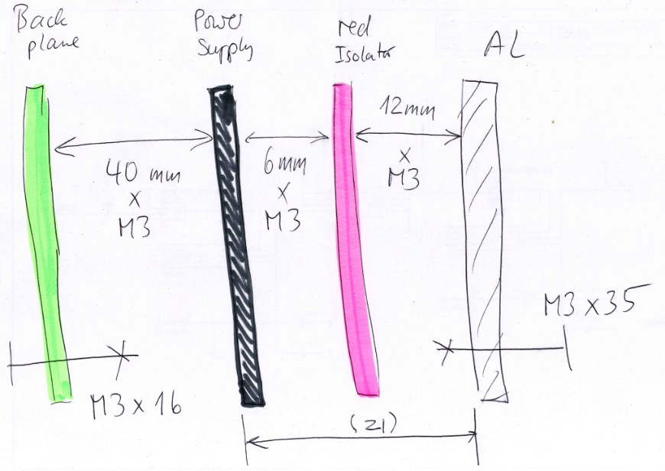

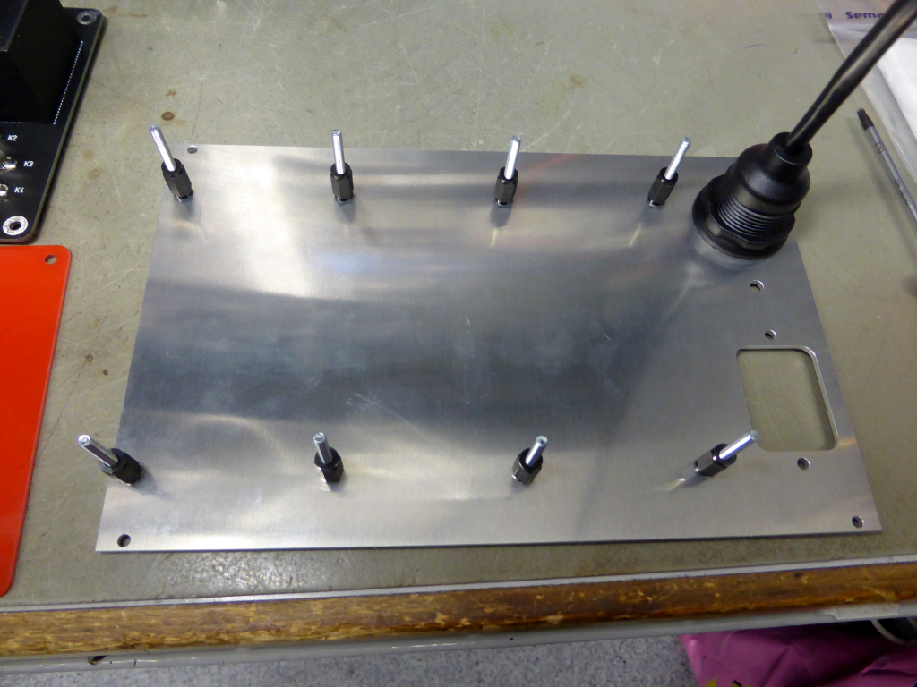

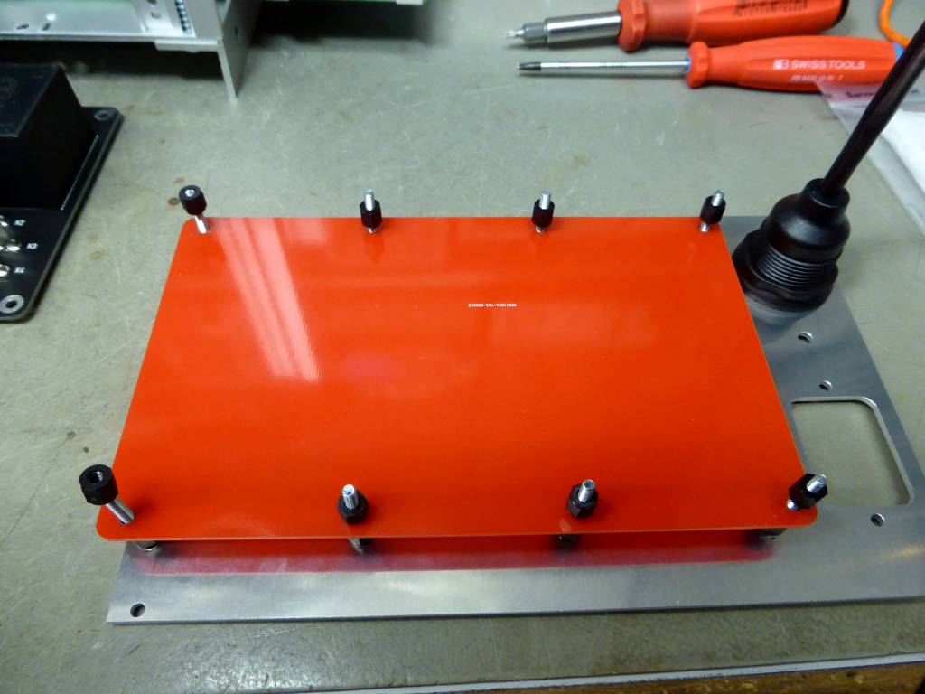

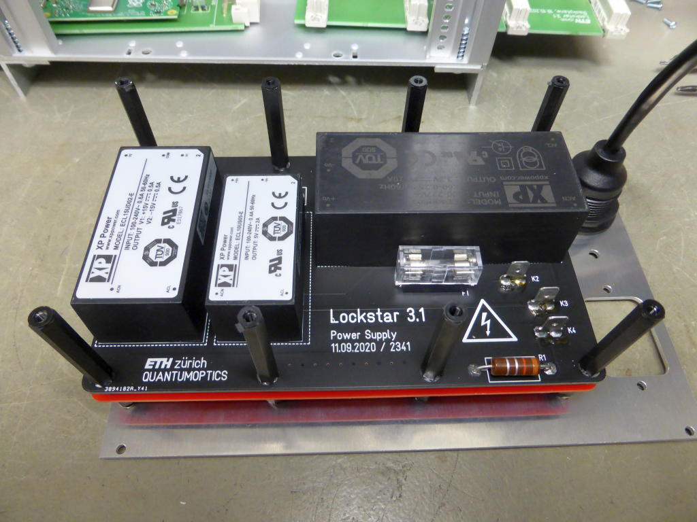

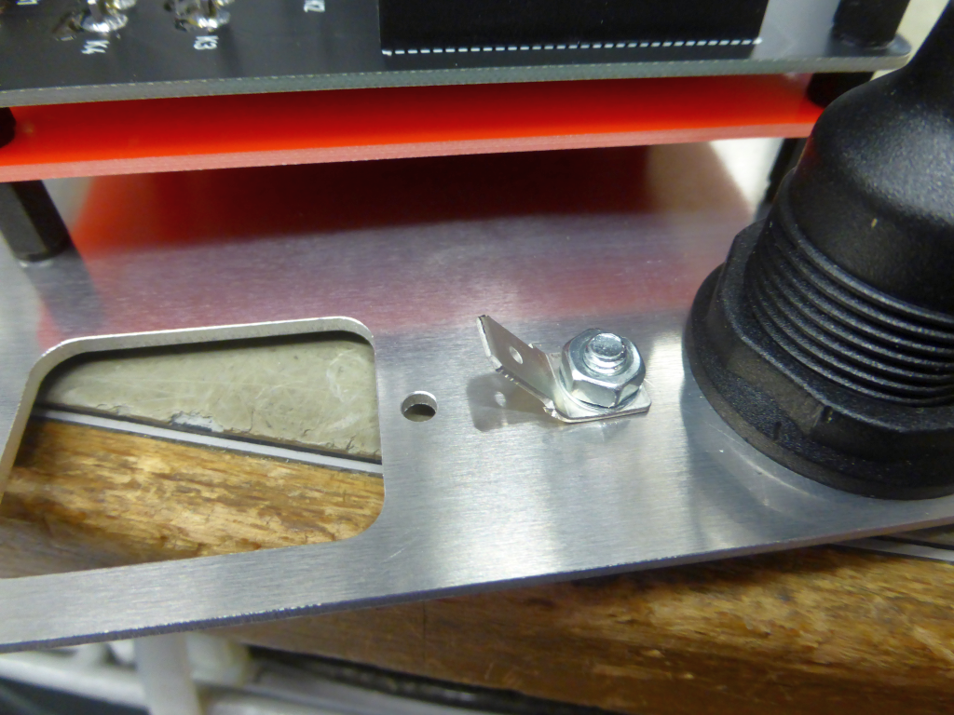

USE M4 with LOCKER AND SECURITY BOLT.

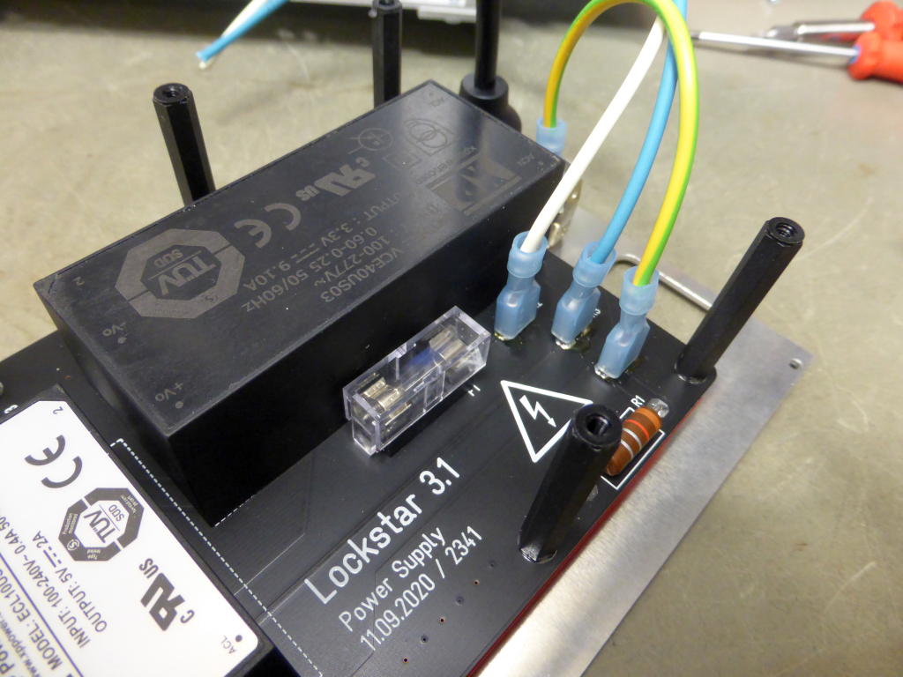

NO CREATIVITY WHEN IT COMES TO COLOURS !

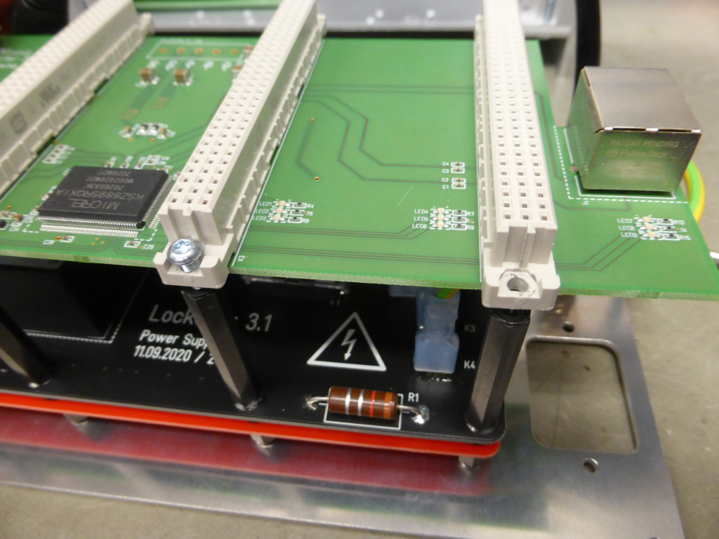

HOLE DIAMETER MAYST BE INCREASED TO 3.1 mm

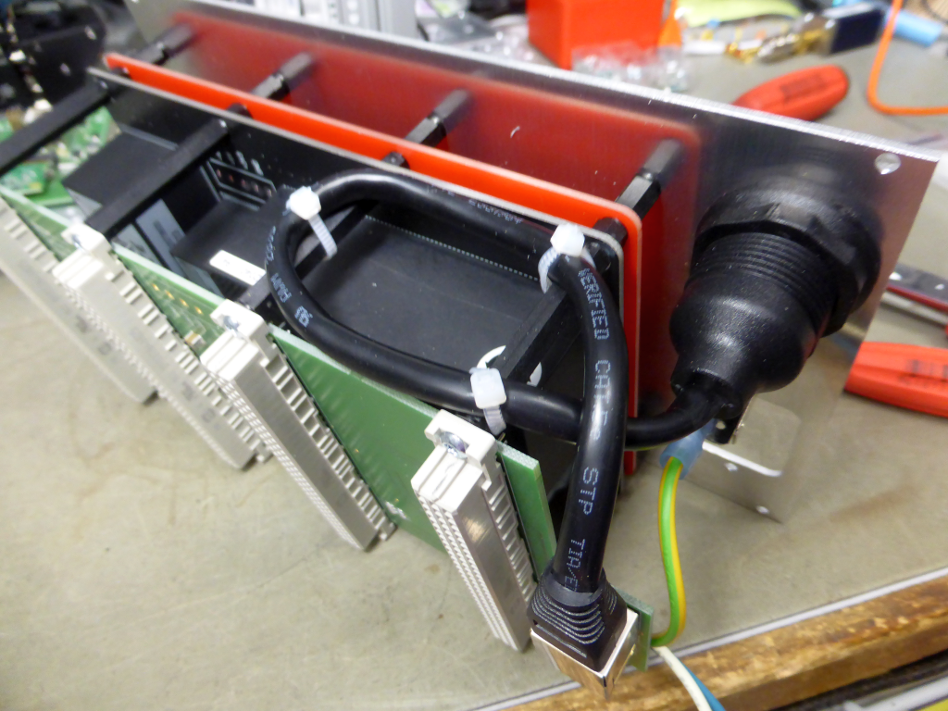

FIX THE ETHERNET CABLE.

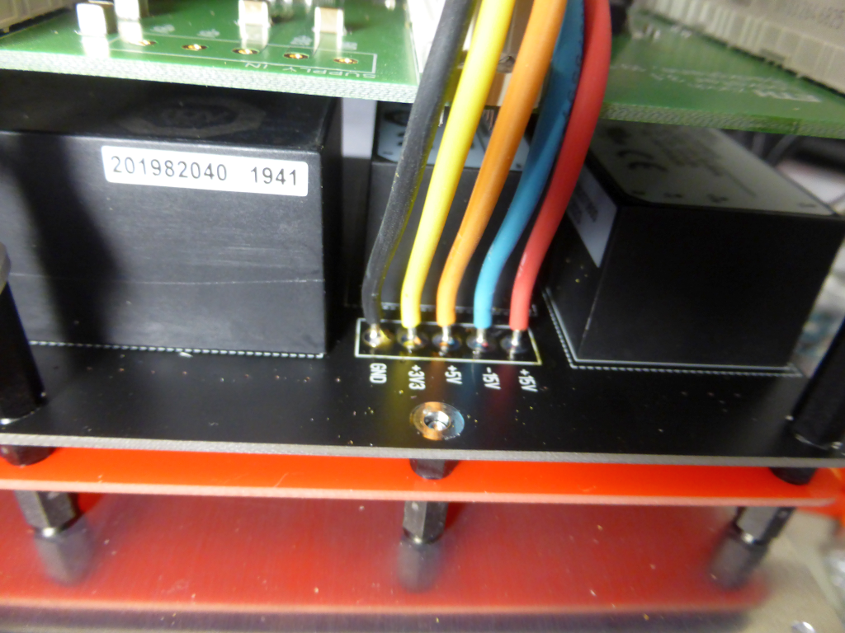

SOLDER CABLES TO THE POWER SUPPLY BOARD

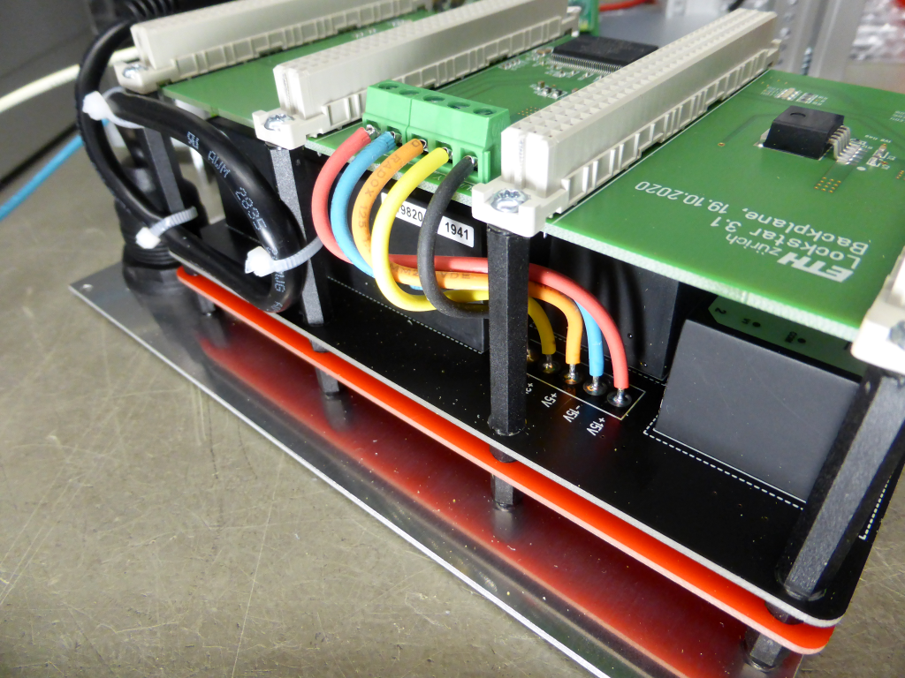

ADD SCREW TERMINAL TO BACKPLANE AND CONNECT THE WIRES.

TRIPLE CHECK THE CORRESPONDING VOLTAGES. (BEFORE SWITCHING ON :-)

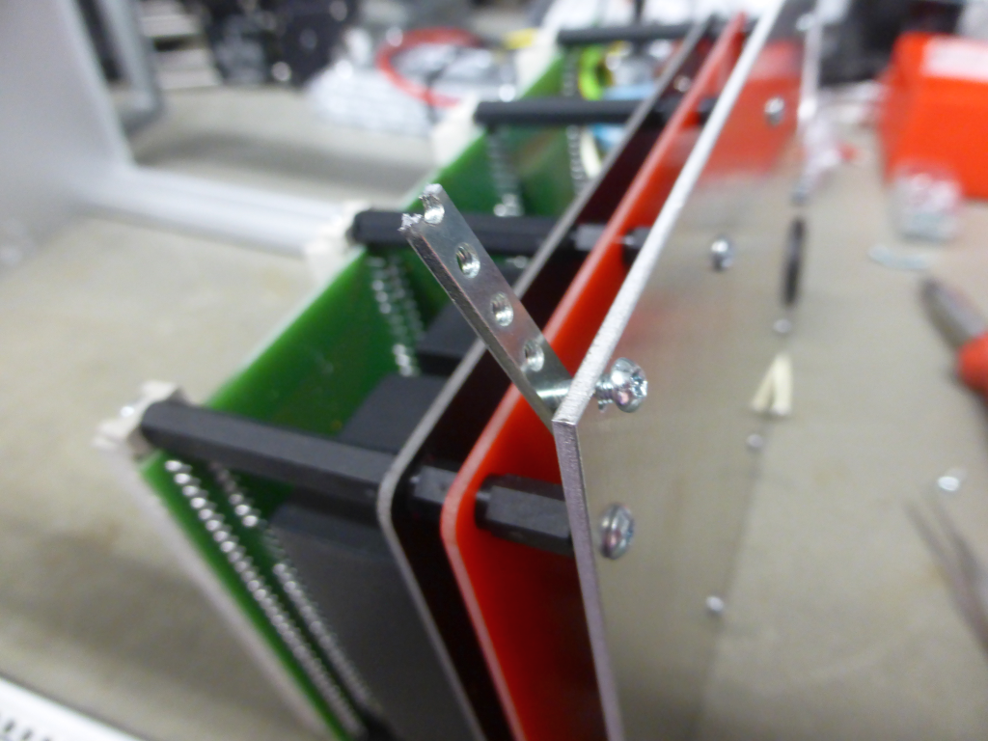

FROM POS. 2 CUT OFF 4 SMALLER PIECES FOR REAR PANEL MOUNTING. USE M2.5 x 8 SCREWS

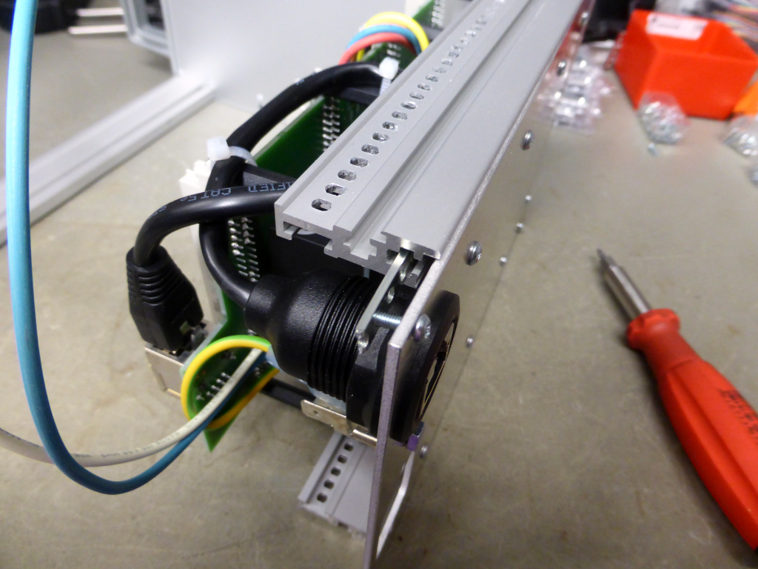

SLIDE IN THE POS2 PIECES INTO RAIL OF CASE.

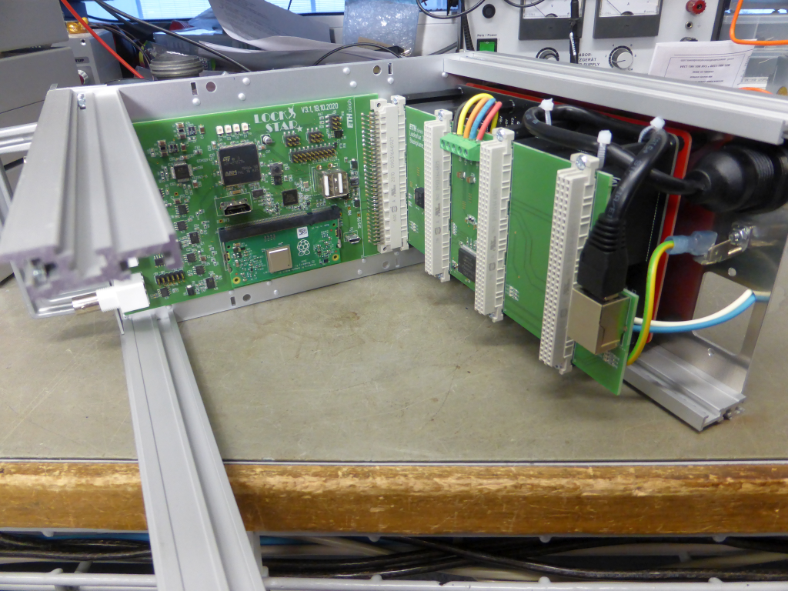

STILL NOT HURT YOURSELF ? BE PROUD AND TAKE A BREAK ...

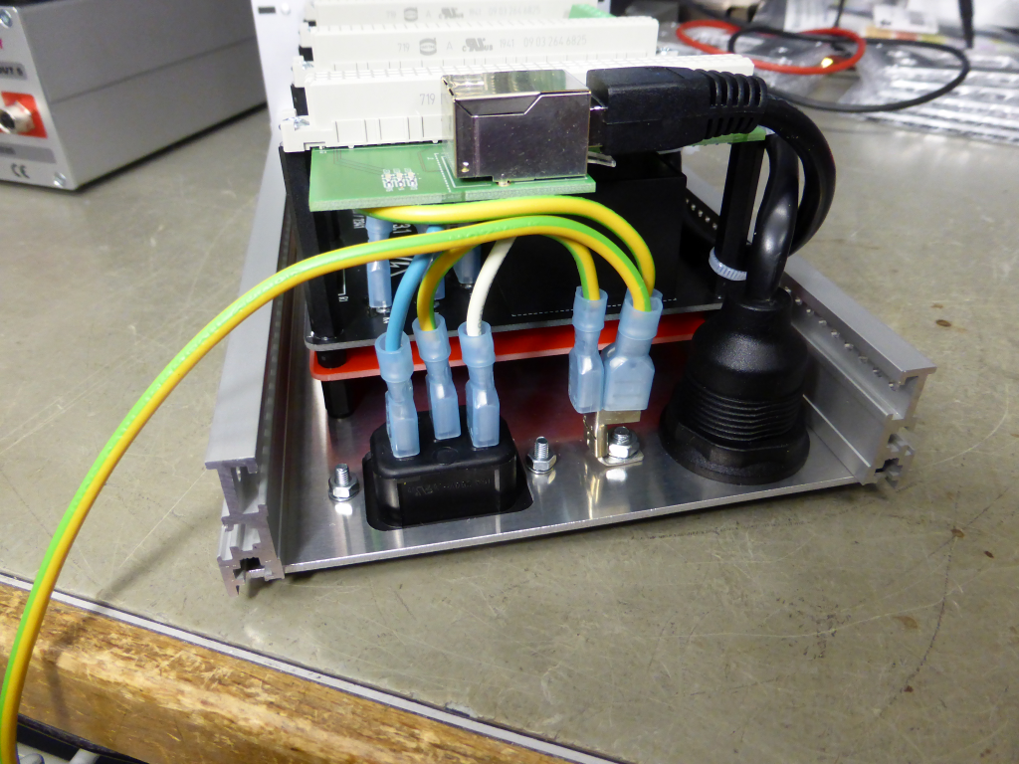

MOUNT POWER CONNECTOR. CONNECT POWER WIRES. DOUBLE CHECK, THAT CRIMPING WAS SUCESSFUL BY PULLING HARD AT THE ENDS.

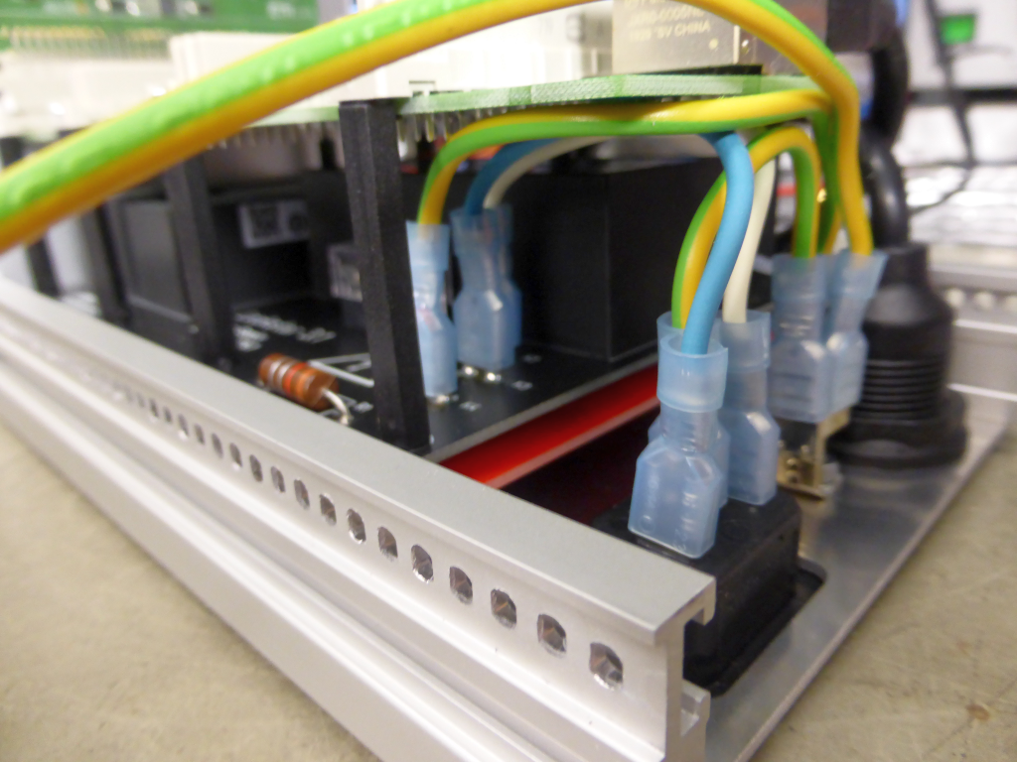

SAME SAME - BUT DIFFERENT VIEWING ANGLE :-)

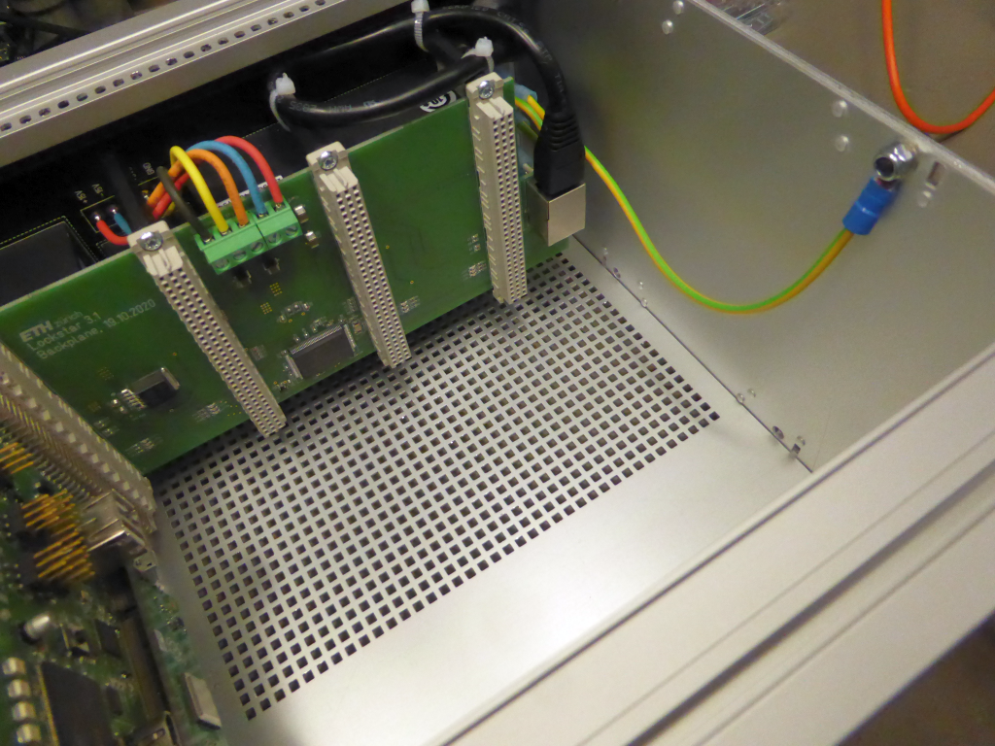

CONNECT AN EARTH WIRE TO THE SIDEWALLS.

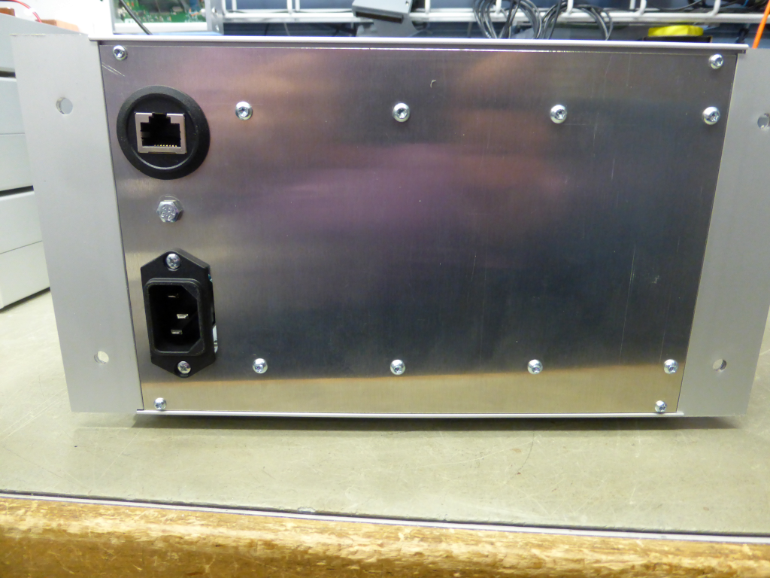

DOUBLE CHECK THE ORIENTATION OF THE POWER CONNECTOR.

**BY COMMAND OF THE BOARD, THE DEVICE MUST BE TESTED ACCORDING TO DIN / VDE 0701 AFTER ASSEMBLY IS COMPLETE.**

**YOU MANUFACTURER ARE RESPONSIBLE FOR THE SECURITY OF THAT THING.**